Old St Paul's Cathedral
© 2003 Armchair Travel Co. Ltd.
This page may be printed or saved to disk
and used for non-commercial purposes ONLY!

Save as Microsoft Print
Word document

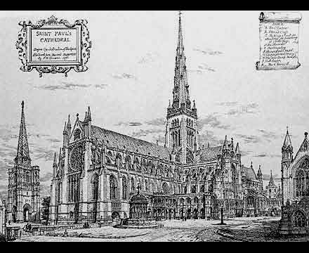

Old St Paul's Cathedral, prior to its destruction in the Fire of London in 1666, was the largest church in Britain, and the third largest in Europe.

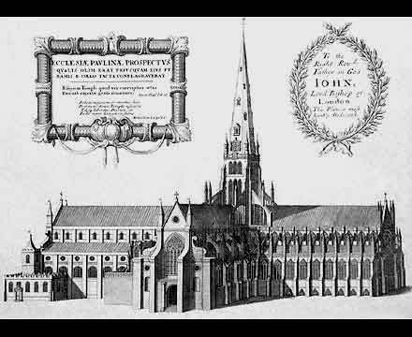

Until 1561, when it was struck by lightning, it had the tallest spire ever built in Britain. The huge building was at the very heart of civic life in London.

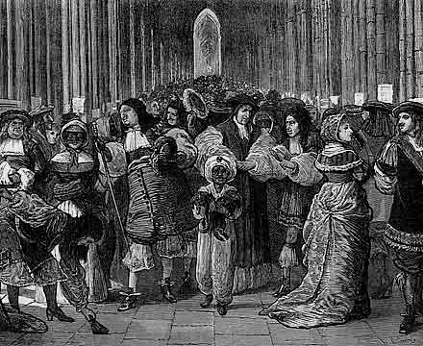
We have a very good idea of how it looked just before its destruction, for Wencelaus Hollar in the 1650's engraved a very full and detailed set of views of it.

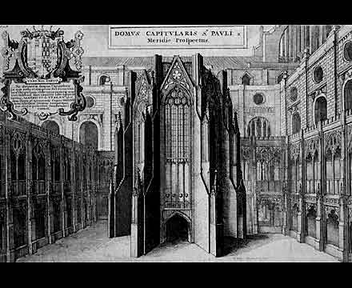

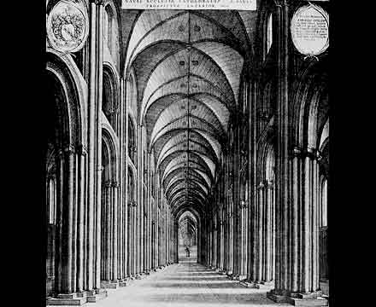
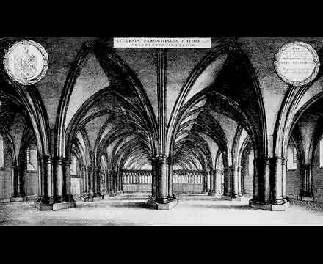

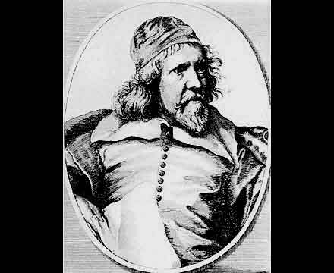

From 1633 onwards Inigo Jones, the foremost architect of his day in England, was engaged in work of restoration and improvement of the old gothic building.

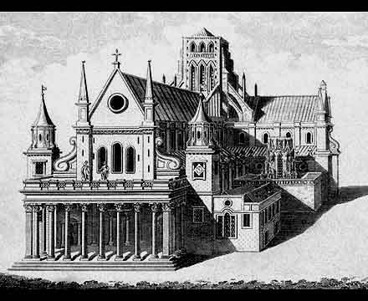

This involved refacing the exterior of the Nave in a classical style, and creating a monumental portico at the West End.

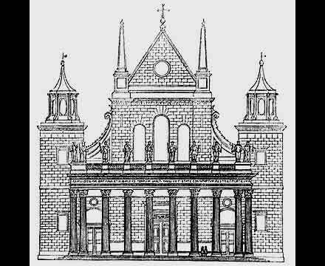

This work ceased at the Commonwealth, and the cathedral was much neglected until the Restoration of the monarchy in 1660.

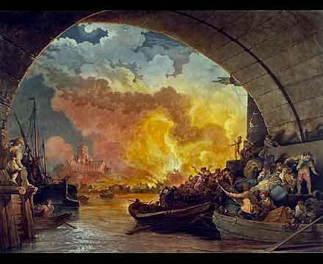

But the old building had not long to stand. Six years later, the fire of London damaged it so radically that it could not be repaired...

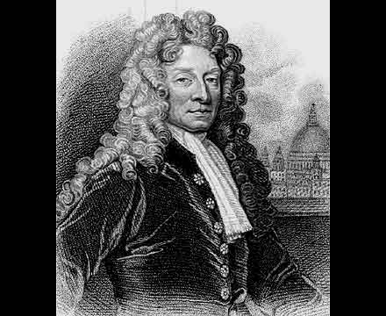

and the new Cathedral began to rise, to the designs of Sir Christopher Wren.

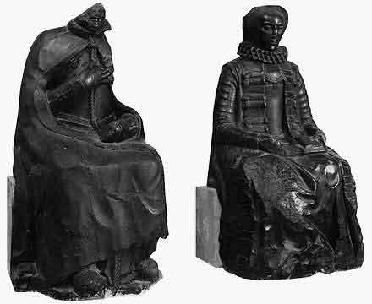

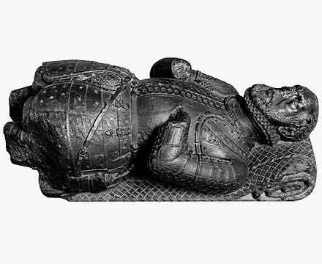

Almost nothing of the old Cathedral remains today. The new Cathedral however, preserves the damaged remains of some of the funerary monuments which survived the fire.

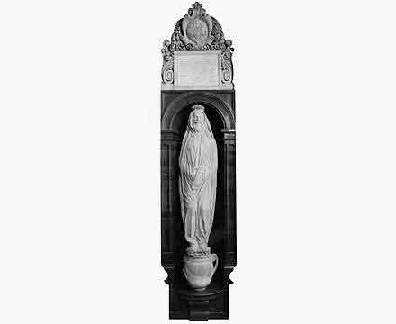

The most famous of these is the extraordinary monument which the poet John Donne commissioned for himself long before his death: it shows him wrapped in his winding sheet after death, and standing on a funerary urn.

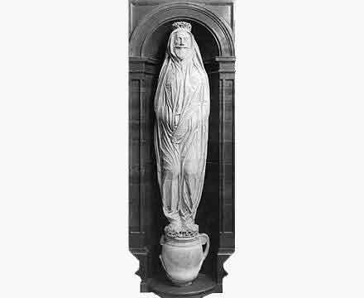

"No man is an Island, entire of it self; every man is a piece of the Continent, a part of the main; if a clod be washed away by the sea, Europe is the less, as well as if a promontory were, as well as if a manor of thy friends or of thy own were; any man's death diminishes me, because I am involved in Mankind; and therefore never send to know for whom the bell tolls; it tolls for thee."
- 'Devotions upon Emergent Occasions', 1624, Meditation XVII

